2021 Central Valley Chapter ASSP Professional Development Conference (PDC)
Virtual Conference - Wednesday, February 2021
Sponsorship Levels

Platinum Sponsors $3000 Gold Sponsor $2000
Company logo on Conference materials and promotional fliers Company logo on Conference materials and promotional fliers
Recognition as Platinum Sponsor on event website Recognition as Gold Sponsor on event website
Social media blasts for Conference Social media blasts for Conference
Six complimentary conference attendees Four complimentary conference attendees
Discount for additional conference attendees Discount for additional conference attendees
Recognition during Conference (breaks, break-out, lunch) Recognition during Conference (breaks, break-out, lunch)
Customizable virtual event booth to interact with attendees Customizable virtual event booth to interact with attendees
Personalized 3-minute Commercial during Conference Logo and link to company on event website
Logo and link to company on event website

Silver Sponsor $1000 Bronze Sponsor $500
Company logo on Conference materials and promotional fliers Company logo on Conference materials and promotional fliers
Recognition as Silver Sponsor on event website Recognition as Bronze Sponsor on event website
Social media blasts for Conference Social media blasts for Conference
Three complimentary conference attendees One complimentary conference attendees
Discount for additional conference attendees Discount for additional conference attendees
Recognition during Conference (breaks, break-out, lunch) Recognition during Conference (breaks, break-out, lunch)
Customizable virtual event booth to interact with attendees Customizable virtual event booth to interact with attendees
Logo and link to company on event website Logo and link to company on event website

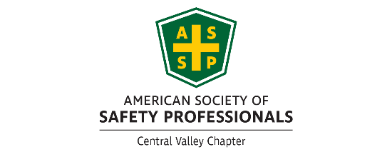
Central Valley Chapter ASSP
Contact any board member or
Email president@centralvalley.assp.org
Central Valley ASSP PO Box 72 Fresno, CA 93721
https://centralvalley.assp.org/

